Activity 1 : Extension Logo change:
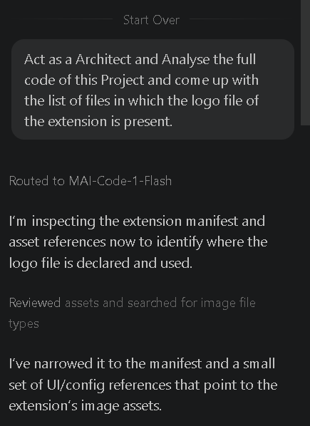
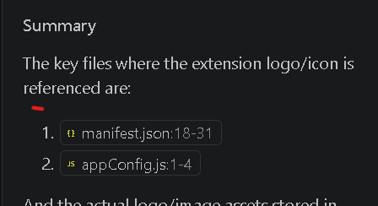

After Browser Logo change
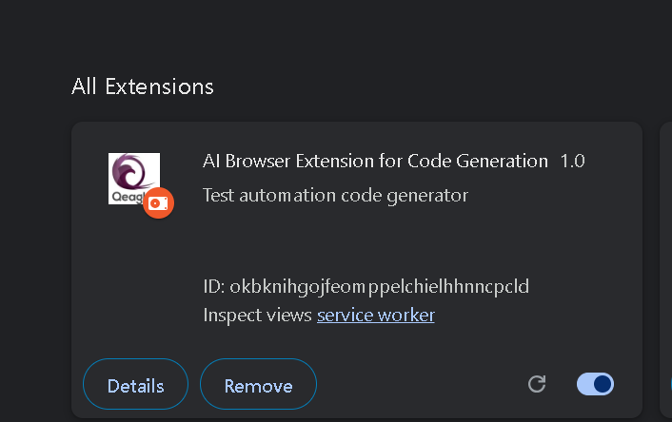

Activity 2: New Model Addition
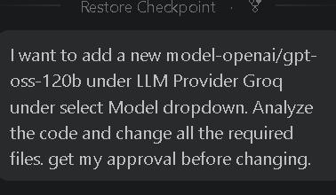

After adding new model :
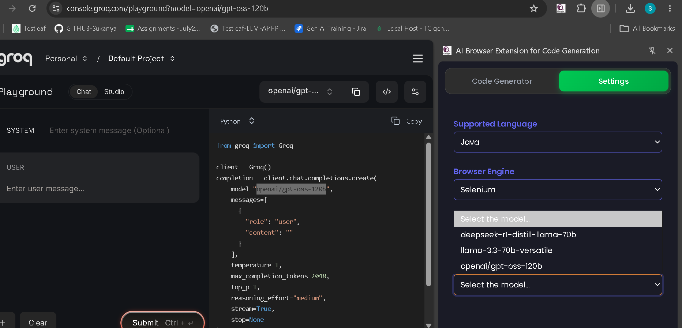

Activity 3 – Playwright typescript code generation
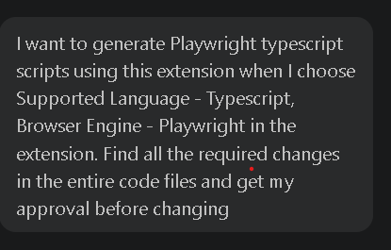

Playwright code:
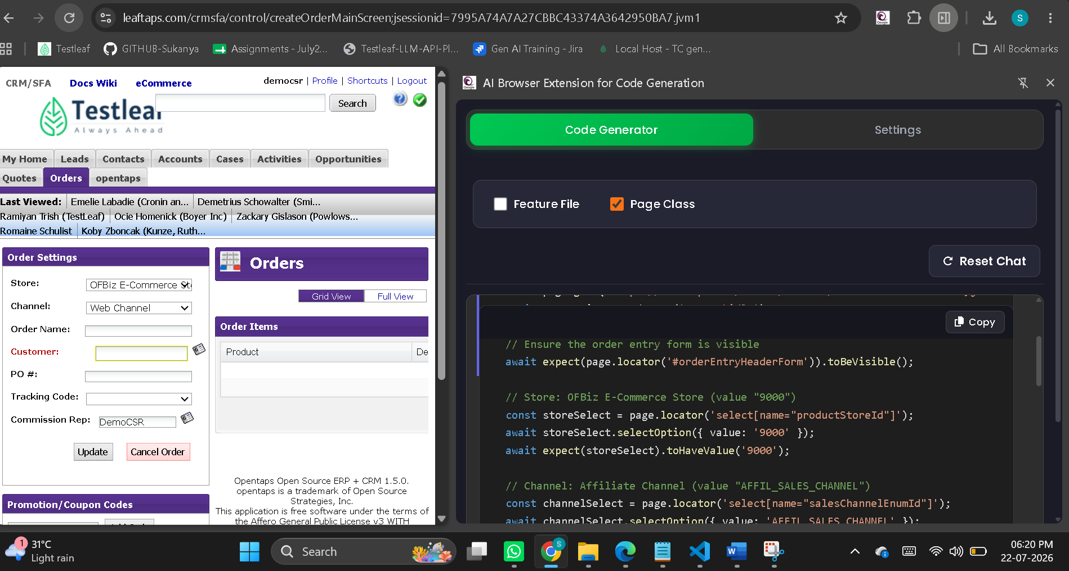

Code Snippet:
import { test, expect } from '@playwright/test';

test('create order flow', async ({ page }) => {
await page.goto('https://leaftaps.com/crmsfa/control/createOrderMainScreen;jsessionid=7995A74A7A27CBBC43374A3642950BA7.jvm1');
await page.waitForLoadState('networkidle');

// Ensure the order entry form is visible
await expect(page.locator('#orderEntryHeaderForm')).toBeVisible();

// Store: OFBiz E-Commerce Store (value "9000")
const storeSelect = page.locator('select[name="productStoreId"]');
await storeSelect.selectOption({ value: '9000' });
await expect(storeSelect).toHaveValue('9000');

// Channel: Affiliate Channel (value "AFFIL_SALES_CHANNEL")
const channelSelect = page.locator('select[name="salesChannelEnumId"]');
await channelSelect.selectOption({ value: 'AFFIL_SALES_CHANNEL' });
await expect(channelSelect).toHaveValue('AFFIL_SALES_CHANNEL');

// Order Name
const orderNameInput = page.locator('input[name="orderName"]');
await orderNameInput.fill('Test Order 001');
await expect(orderNameInput).toHaveValue('Test Order 001');

// Customer (autocomplete)
const customerInput = page.locator('#ComboBox_updateOrderHeaderInfoPartyId');
await customerInput.fill('DemoCustomer');
// pause briefly for autocomplete suggestions to load (if any)
await page.waitForTimeout(500);

// PO #
const poInput = page.locator('input[name="poNumber"]');
await poInput.fill('PO12345');
await expect(poInput).toHaveValue('PO12345');

// Tracking Code: 9102 Automobile Mag Ad
const trackingSelect = page.locator('select[name="trackingCodeId"]');
await trackingSelect.selectOption({ value: '9102' });
await expect(trackingSelect).toHaveValue('9102');

// Commission Rep
const repInput = page.locator('#salesRepPartyId');
await repInput.fill('DemoCSR');
await expect(repInput).toHaveValue('DemoCSR');

// Submit the form
await page.locator('#mainSubmit').click();

// Wait for any post‑submission processing
await page.waitForLoadState('networkidle');

// Verify that a confirmation message appears (adjust selector/text as needed)
await expect(page.getByText(/order.*updated/i)).toBeVisible({ timeout: 5000 }).catch(() => {});
});

